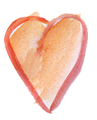

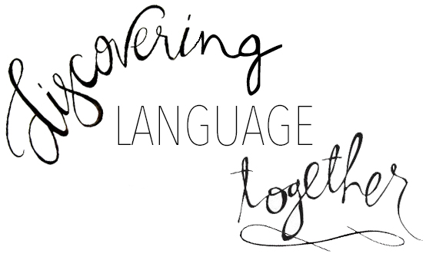

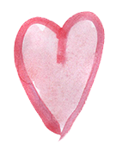
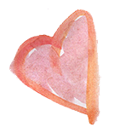

Come and expand your American Sign Language skills with Liz and Conrad, our Deaf Mentors. This monthly ASL event will allow you to learn new signs connected to a specific theme, build on language, learn some fascinating information about Deaf Culture/Deaf History, and use it in everyday conversation with your child(ren).
The next monthly theme is:

“Animals in Winter”
February 7th from 5:15-6:15
MECDHH Cafeteria, Mackworth Island, Falmouth

Please register by February 2nd.

**Bring your own snacks!**

Mary Jo York
1 Mackworth Island, Falmouth, ME 04105
maryjo.york@mecdhh.org

Save these dates for Future Gatherings!
March 21st, 2018;
April 11th, 2018 & May 9th, 2018; & June 6th, 2018!

Questions call (207) 781-6215

